# Getting Started – Updating Laptops (Quick List)

Log onto the Guest Wi-Fi and search the internet to download & install the latest versions of the following list of programs. If given the option: chose to install for all users on the laptop and also chose to add a shortcut to the desktop.

|  |  |
| --- | --- |
|  | 1. FRC 2024 Tools |
|  | 1. WPI Library |
|  | 1. WinMerge |
|  | 1. WinScp |
|  | 1. Notepad ++ |
|  | 1. VS Code |
|  | 1. Rev Hardware Client |
|  | 1. Phoenix Framework for FRC (CTRE) |
|  | 1. AdvantageScope (Team 6328) – from GitHub |
|  | 1. PathPlanner – from GitHub |
|  | 1. Visual Studio Community Edition (needed for simulations)   Loading the Toolsets for:  Python  Net Desktop Development  Desktop Development C++ |
|  | 1. 7 Zip |
|  | 1. Balena Etcher |
|  | 1. Doxygen |
|  | 1. GraphViz |
|  | 1. Git |
|  | 1. Phoenix Tuner X (CTRE) |

# Getting Started – Updating Laptops (Supplemental Detail)

* **FRC 2024 Tools**

* **WPI Library**

* **WinMerge**

* **WinScp**

* **Notepad ++**

* **VS Code**

* **Rev Hardware Client**

* **Phoenix Framework for FRC (CTRE)**

* **AdvantageScope (Team 6328) (Download from GitHub)**

* **PathPlanner (Download from GitHub)**

* **Visual Studio Community Edition (including the toolsets for Python, Net Desktop Development, and Desktop Development C++)**

* **7 Zip**

* **Balena Etcher**

* **Doxygen (for software documentation)**

* **GraphViz**

* **Git (64 bit for windows)**

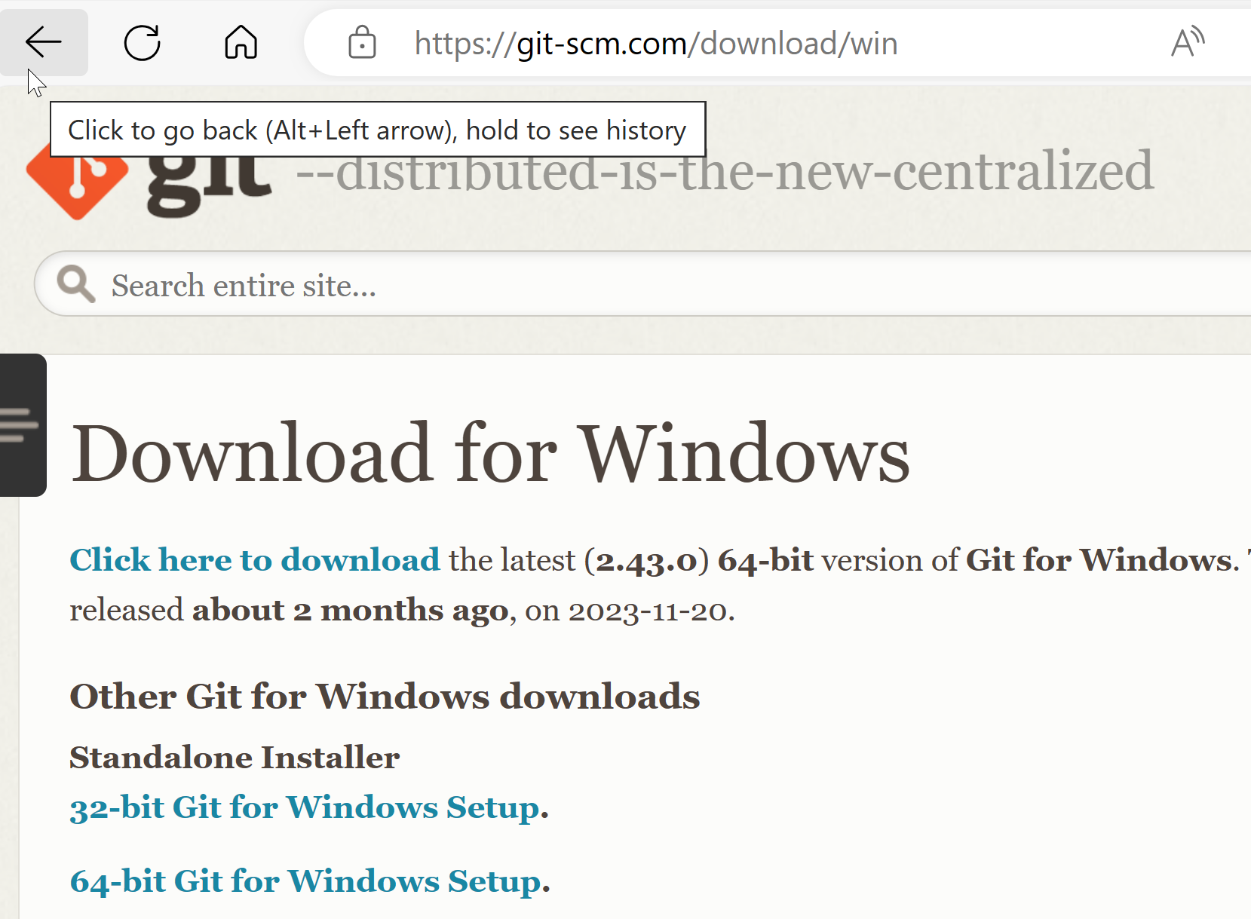

* **Phoenix Tuner X (CTRE)**

Download from Microsoft app store

